End-to-End Machine Learning Project
Final Task 1 Report

1. Problem Definition
Just over half of all order lines in this dataset lose money. Sales figures look healthy while profit does not. The business needs to know which orders are the risky ones before they are fulfilled, not after.
Framed as a machine learning problem, this is binary classification: for each order line, predict Profitable = 1 if the order made money and 0 if it lost money.
Classification was chosen over regression deliberately. Predicting the exact profit amount sounds more useful but is much harder and less reliable, and a manager mainly needs to know whether to look at an order more closely, which is a yes or no question.

Success criteria, set before any modeling
Criterion | Target | Final result | Status
Beats majority-class guessing | Above 50.8% | 95.4% | PASS
Useful enough to act on | At least 85% accuracy | 95.4% | PASS
Balanced errors | Precision above 0.80 | 0.965 | PASS
Balanced errors | Recall above 0.80 | 0.940 | PASS
Explainable | Drivers can be named | Yes | PASS

Setting these before starting matters. Otherwise it is too easy to look at whatever score comes out at the end and declare it good.

2. Dataset and Validation
The dataset is Superstore Sales, 8,399 order lines across 21 columns covering four years of trading. Before any analysis, six validation checks were run, because running an analysis on broken data produces confident nonsense, which is worse than no analysis at all.
Check | Count found | Result
Duplicate rows | 0 | PASS
Missing values | 63 | FOUND
Sales <= 0 | 0 | PASS
Order Quantity <= 0 | 0 | PASS
Discount outside 0 to 1 | 0 | PASS
Ship Date before Order Date | 0 | PASS

Five of the six checks passed. The only issue is 63 missing values in Product Base Margin, which is 0.75 percent of the dataset. These were filled with the median margin of the same product category, which is more accurate than a single global median and keeps every sale in the analysis. Dropping the rows would have lost 63 real sales for the sake of one missing field.

3. Exploratory Analysis
Only the findings that actually changed a modeling decision were kept. The aim was to understand the problem, not to produce every chart possible.
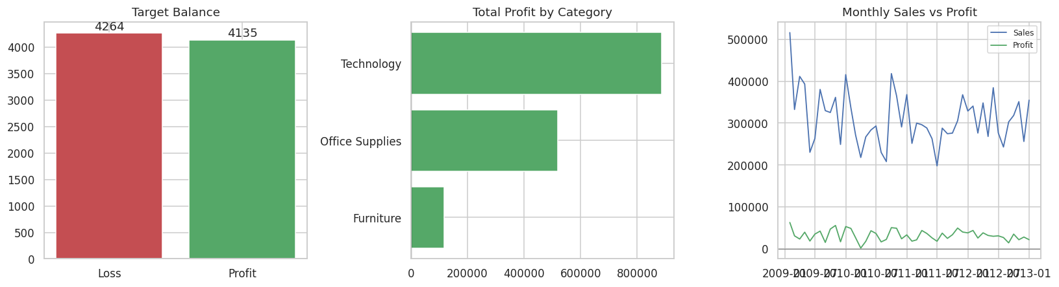
Figure 1: Target balance, profit by category, and monthly sales against profit
- The classes are almost even, 49.2 percent profitable against 50.8 percent not. This means accuracy is a fair metric and no resampling is needed. It also sets the bar, because always guessing loss would score 50.8 percent.
- Sales and Profit correlate at only 0.58. A large sale does not mean a large profit. This was the most important finding, because it says the raw Sales column alone will not solve the problem, and it pointed directly at the feature engineering that followed.
- Profit sits close to break-even in every month even when sales are high, so this is a structural margin problem rather than a seasonal dip.
- Furniture sells well but returns very little profit, so product type carries real signal and the categorical columns are worth keeping.
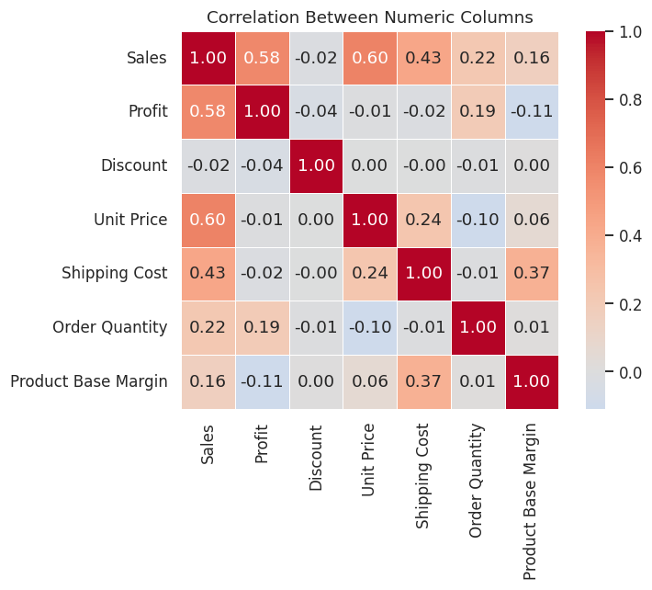
Figure 2: Correlation between the numeric columns

4. Feature Engineering
Five new features were created from columns that already exist. Each one exists for a reason connected to a finding above, rather than because it was easy to calculate.
Feature | Formula | Reason
Shipping Delay | Ship Date - Order Date | A slow shipment can point to a bulky or awkward product
Revenue Per Unit | Sales / Order Quantity | Separates cheap bulk orders from expensive small ones
Shipping Cost Ratio | Shipping Cost / Sales | EDA showed sales does not equal profit; this measures what shipping eats
Discount Value | Sales x Discount | 10% off a 5,000 order is very different from 10% off a 50 order
Order Month | Month of Order Date | Allows the model to pick up any seasonal pattern

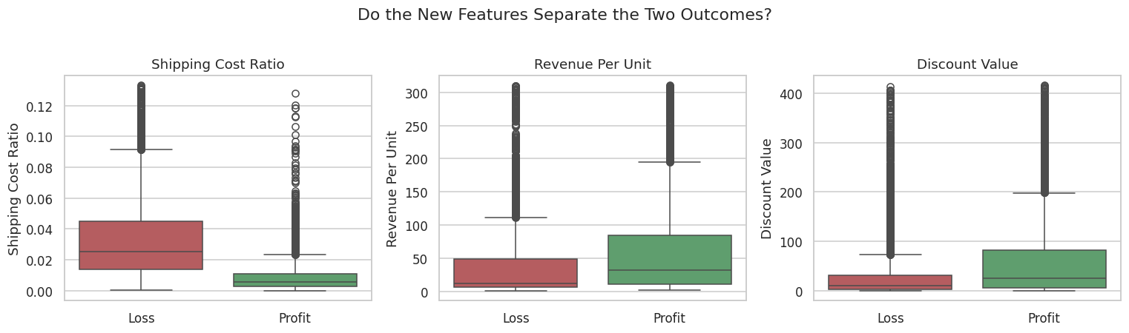
Figure 3: Do the new features separate the two outcomes?
Shipping Cost Ratio separates the two groups clearly, with loss-making orders showing a much higher ratio. This is the feature that directly answers the sales-does-not-equal-profit finding from the exploratory analysis.

5. Train, Validation and Test Design
This was the most important design decision in the project.
Weeks 2 and 3 used a simple train/test split. That has a problem: if several models are compared on the test set and the best one is chosen, the test set has been used to make a decision. Its score is then optimistic, because the winner was partly selected by luck on those specific rows.
The fix is three sets, each with exactly one job.
Set | Rows | Share | Job
Training | 5,039 | 60% | The models learn from this
Validation | 1,680 | 20% | Models are compared here and the winner chosen
Test | 1,680 | 20% | Opened once at the end, never used to decide anything

All three sets keep almost the same class balance because stratify was used at both split steps. Numeric columns are scaled and categorical columns one-hot encoded inside a Pipeline, so the transformers are fitted on the training data only. If the scaler had seen the validation or test data, those scores would be inflated.

6. Baseline and Model Comparison
Before anything clever, a dummy classifier that always guesses the majority class was trained. It scored 0.5077 on the validation set. Any model below that is adding nothing, no matter how complex it looks.
Four models were then trained on the training set and compared on the validation set. The test set was not involved at this stage.
Model | Accuracy | Precision | Recall | F1 | ROC-AUC
Dummy (baseline) | 0.5077 | - | - | - | 0.5000
Logistic Regression | 0.8720 | 0.8600 | 0.8839 | 0.8718 | 0.9333
Decision Tree | 0.9065 | 0.9026 | 0.9081 | 0.9054 | 0.9373
Random Forest | 0.9327 | 0.9429 | 0.9190 | 0.9308 | 0.9824
Gradient Boosting | 0.9345 | 0.9487 | 0.9166 | 0.9323 | 0.9841

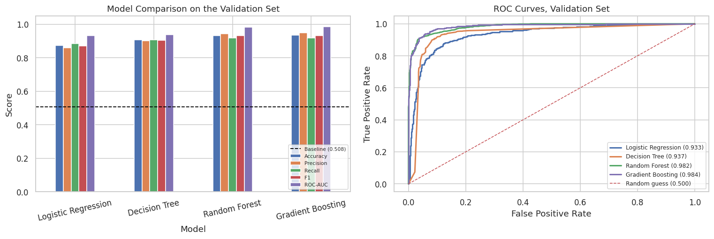
Figure 4: Model comparison and ROC curves on the validation set

Why Gradient Boosting was chosen
- Scores. It has the best ROC-AUC on the validation set, and ROC-AUC is the fairest single number here because it does not depend on where the decision threshold is set.
- Balanced errors. Precision and recall are close together, meaning it is not achieving its score by being reckless in one direction.
- Explainable. It reports feature importances, which are used for interpretation and again in Final Task 2 to explain the model to a non-technical reader. Logistic Regression is easier to explain still, but it is the weakest performer here.

7. Final Evaluation on the Held-Out Test Set
The test set was opened at this point, for the first and only time. Nothing after this changed the model. If it had, the number below would stop being honest.
Metric | Validation set | Test set (final)
Accuracy | 0.9345 | 0.9536
Precision | 0.9487 | 0.9652
Recall | 0.9166 | 0.9395
F1 | 0.9323 | 0.9522
ROC-AUC | 0.9841 | 0.9886

The test score came out slightly higher than the validation score, which can look suspicious at first. It is normal variation: both sets are 1,680 rows drawn randomly, so a difference of about two points is well within what you would expect by chance. What matters is that the two are close. If the test score had come out far lower than validation, that would mean the model had been over-fitted to the validation set during model selection, and the comparison in section 6 could not be trusted.
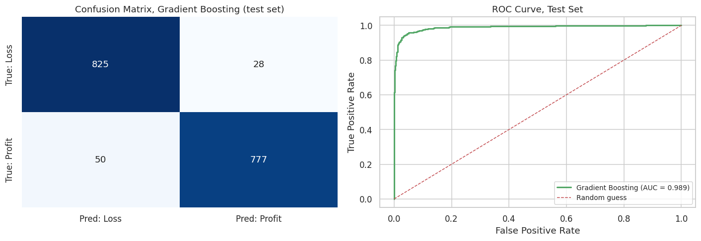
Figure 5: Confusion matrix and ROC curve on the held-out test set
On the 1,680 test rows the model produced 825 true negatives, 777 true positives, 28 false positives and 50 false negatives. The 28 false positives are losing orders that were approved. The 50 false negatives are profitable orders wrongly flagged as risky, which in business terms means turning away good business. That balance shapes the recommendation in section 9.

8. Interpretation
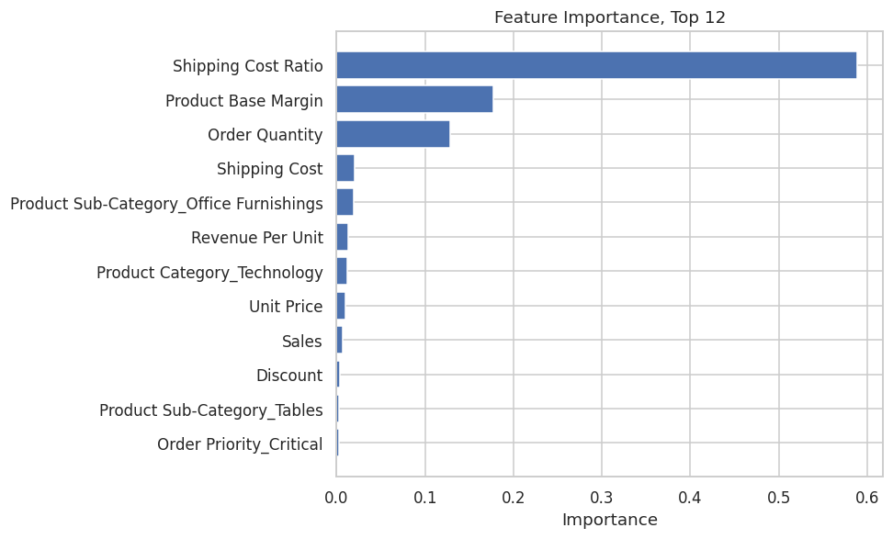
Figure 6: Feature importance, top 12
Feature | Importance
Shipping Cost Ratio | 0.5887
Product Base Margin | 0.1776
Order Quantity | 0.1285
Shipping Cost | 0.0207

Shipping Cost Ratio is the strongest driver by a wide margin, and it is one of the five features created in section 4 rather than a column that came with the data.
Importance says a feature matters but not which direction it pushes, so the feature was split into five equal bands and the real profit rate measured in each.
Shipping Cost Ratio band | Orders | Profit rate | Average profit
Very Low | 1,680 | 90.4% | 1,106.74
Low | 1,680 | 78.3% | 166.29
Medium | 1,679 | 49.1% | -103.45
High | 1,680 | 20.6% | -148.11
Very High | 1,680 | 7.7% | -115.72

Where shipping takes a small share of the sale, about 90% of orders make money. Where it takes a large share, under 10% do.

9. Final Recommendation
Adopt the model as a warning system, not as an automatic gatekeeper. It should flag high-risk orders for a person to review rather than reject them on its own.
The reason is in the confusion matrix. The model makes mistakes in both directions, so letting it reject orders automatically would turn away 50 genuinely profitable orders out of every 1,680 processed.
The business action that matters most does not even need the model. Shipping Cost Ratio is the dominant driver, so reviewing shipping costs on cheap, bulky products is the highest-value step available, and the band table above supports it directly.

10. Challenges
- Deciding what to do about outliers. Sales and Profit contain many statistical outliers, but a 10,000 order or a large loss is a real business event, not a data error. Removing them would have hidden the exact transactions the business needs to see, so they were kept.
- Avoiding accidental cheating. Profit had to be dropped from the features, since the target is derived from it. Leaving it in would have produced a near-perfect score that meant nothing at all.
- Trusting the score. Comparing four models on a test set and then reporting that test score would have been optimistic. Adding the validation set solved this, at the cost of a smaller training set.

11. Limitations
- No cost-of-goods column. The model estimates profitability from price, discount and shipping. This is a hard ceiling on how accurate it can ever be.
- Predictions are per order line, not per customer. An order that loses money but wins a valuable long-term customer looks like a plain failure to this model.
- The split is random, so two lines from the same order can land in different sets. Splitting by order ID would be more correct.
- No hyperparameter tuning was done, so the model is probably not at its best.
- The decision threshold is fixed at 0.5, which assumes approving a bad order costs exactly what rejecting a good one costs. Nobody has checked that.
- The model was trained on four-year-old historical data. A change in pricing or shipping policy would make parts of it out of date.

12. Future Improvements
- Add cost-of-goods data. This is the single highest-value fix and every other limitation is smaller than it.
- Split by Order ID so a whole order always stays in one set.
- Tune the chosen model with GridSearchCV.
- Add customer-level features, such as how many orders a customer has placed before.
- Set the decision threshold from real business costs instead of leaving it at 0.5.
- Deploy it and monitor it, which is exactly what Final Task 2 covers.

